 | 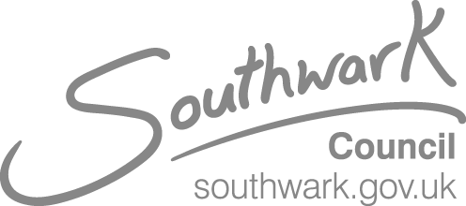
Click here to enter recipient name and address, max 5 lines. | Pauline O’Hare  Director of Adult Social Care  Adult Social Care  Click here to enter sender’s Business Unit.  Pauline.O’Hare@southwark.gov.uk  Tel: 020 7525 0582  Date: 31 October 2024  Ref: Click here to enter reference.
Dear Click here to enter recipient name.
Re. Short breaks consultation
I am writing to you as a carer of an adult who has been in receipt of specialist overnight short breaks, either from Orient Street, or purchased elsewhere in the last twelve months.
We wrote to you in October 2023 to inform you that the council was reviewing and consulting on how short breaks are delivered for adults with Learning Disabilities. A number of in person and online engagement sessions were held during the consultation including one to one meetings.
I would like to thank you for your engagement and feedback. All of the feedback that was received has been reviewed and used by the council when considering what the future shape of the adult short break offer in Southwark will be.
I understand how important our services are to you and your family and so am pleased to confirm that we will continue to deliver specialist overnight adult short breaks from Orient Street for those families and individuals who are assessed as being eligible for an overnight short break. During the course of the consultation, feedback identified areas of the service that we will work closely with families to improve including reducing cancellations and improving communication.
We will also be expanding the Orient Street offer to support eligible adults with enablement stays to improve their independence, life skills and where appropriate facilitate multi-disciplinary support.
I would like to invite you to one of our consultation update meetings that will be hosted by Kerry Rabey, Head of Service for All Age Disability & Learning Disability (25+) service. They will provide an opportunity for us to discuss the improvements to the service that will be delivered. There will be sessions held virtually and in person and will take place on the following dates-
- 9.30am-10.30pm, 18 November 2024 Dulwich Library, 368 Lordship Ln, London SE22 8NB
- 1.30pm- 2.30pm, Pod 1, 19 November 2024, Peckham Library, 122 Peckham Hill St, London SE15 5JR
- 5pm-6pm, 20 November 2024, virtual online meeting via Microsoft Teams
If you would like to attend a session please can you book at
Southwark Adult Social Care Short Breaks Consultation - What we've done... Tickets, Multiple Dates | Eventbrite to secure your place. Booking opens from Monday 4 November 2024. The All Age Disability & Learning Disability (25) service will be in contact with you to arrange reviews during the consultation process.
The consultation update report and this letter can be found at https://engage.southwark.gov.uk/en-GB/projects/community-adult-short-breaks
If the adult that you care for needs a short break you are encouraged to contact your allocated worker or the duty team on 020 7525 2333.

Yours sincerely

Pauline O’Hare
Director of Adult Social Care

