Proposed removal of street tree (Desenfans Road SE21 7DN)- REPORT

Participation Metrics
Metric | Value
Visitors | 57
Phase participants | 17
Participation rate | 29.8%
Surveys submitted | 17
Completion rate | 94.4%

Participation over time
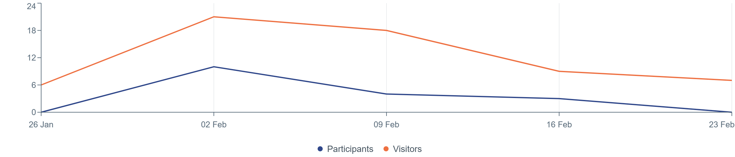



Analysis
Summary:
The overwhelming majority of respondents support the removal of the street tree, primarily due to the foul smell produced by its fruit, which many describe as “horrendous” or “abominable” and a significant blight on daily life. Several respondents also mention the mess and slip hazard caused by the fallen fruit as a safety concern. There is strong appreciation for the council’s responsiveness and for plans to replace the tree, with many specifically requesting or supporting replacement with a male tree or a different species that does not produce smelly fruit. Only one response expresses opposition to the removal, citing the tree’s age, environmental benefits, and contribution to air quality. Overall, the dominant trend is strong support for removal and replacement due to the negative impact of the tree’s fruit on residents’ quality of life.

Responses
Agree with removal
Delighted that it will be removed and replaced with a male variety which will not create a terrible smell every year will be such a relief.
I agree
I am in complete agreement to the removal of the female tree due to the foul smell of the fruit which blights the street for 6 months or more of the year
I fully support the removal and replacement of this tree. The fruit falls and is slippery and smelly. Thank you
I fully support the removal of the tree- it is foul smelling and produces a lot of foul smelling fruit
I never thought I’d be so happy to see a tree cut down. But I am delighted. It has been a blight on our street and has negatively affected our life (and the smell of our hallway, the smell of our buggy, and the state of our car’s paintwork) on a daily basis during the months it bears fruit.
I support the removal of the female gingko because when it is in fruit, the foul smell comes in through my bedroom window.
I support the replacement of a tree that causes risk slipping and falls from excessive fruit.
I would like the tree to be removed
It is a great relief that this tree is being removed due to the tremendous amount of ‘fruit’ that causes so much mess on the pavement and is a very dangerous slip hazard, alongside the abominable stench the fruits give off which is totally overwhelming. Thank you for listening to the residents and acting and replacing the tree with a more appropriate species.
Please do remove asap. The smell caused by the fruit is completely horrendous! Please replace with maple tree if possible. There is a gorgeous one just up from the offensive tree.
Thank you for listening to our concerns about this tree and for taking action to remove it and replace it with a male tree.
The tree should be removed
This is a magnificent tree and is probably about a 100 years old. Trees help the environment a great deal but especially the air quality. We have made Dulwich more people friendly and removed cars. Now , you are taking a step in the opposite direction. By removing this tree, you are breaking the laws of respect for clean air and environment.
Comment from Tree officer: The tree is not 100years its estimated at 30-40years of age
We are committed to replanted a tree to mitigate the loss

Conclusion

Following the Duty to Consult consultation and the overwhelming responses the council have taken the decision to remove the tree and replace it with another tree in the upcoming planting season.

