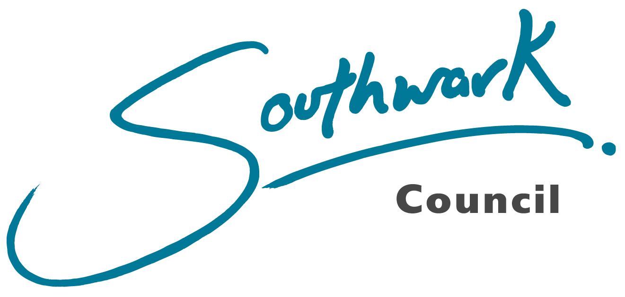

Equality Impact and Needs Analysis - Resident Engagement Strategy

Section 1: Equality impact and needs analysis details

Proposed policy/decision/business plan to which this equality analysis relates | - Resident Engagement Strategy

Equality analysis author |  | Jessica Leech
Strategic Director: |  | Hakeem Osinaike
Department |  | Housing |  | Division |  | Landlord Servics
Period analysis undertaken |  | November 2024 - October 2025
Date of review (if applicable) |  | January 2028
Sign-off | Abi Oguntokun | Position | Director of Landlord Services |  | Date

Section 2: Brief description of policy/decision/business plan

1.1 Brief description of policy/decision/business plan
- The goal of the Resident Engagement Strategy is to put residents at the heart of everything we do as a landlord, empowering tenants, leaseholders and the people who live in council homes to shape the places they live in and make decisions about the issues that affect their lives.

- The resident engagement strategy forms the key element in the delivery of the Good Landlord Plan and the ‘Stronger Voice’ commitment.

- We sought both a breadth and depth of insight to shape this strategy. The draft strategy was informed by a literature review and insights gathered from over 500 council tenants and leaseholders regarding their appetite for engagement.

- The revised version responds to the additional contributions made in the following ways:
  - Surveys on the engagement hub (328), and the tenant satisfaction measures survey of people in our homes (2,261).
  - Expert insight including the Regulator of Social Housing judgement, those who are active and have considerable experience of engagement with the council through our engagement with Southwark Group of Tenant Organisations, (SGTO) Tenant Forum (TF), Homeowner Forum (HOF), Southwark Tenant Management Organisations Committee (STMOC), Local Housing Forums (LHF) and Housing Scrutiny Commission.
  - Workshops on 5 different estates one in each of the LHF areas to do a deep dive with residents who are not most active in the tenant's movement to ensure a breadth of conversation is informing the final strategy alongside discussion at the disability forum and youth parliament adding new perspectives.

- Social Life was appointed by a panel of residents to explore the underlying issues and themes influencing how residents respond to our engagement activities. It was important that there was an independent review of the data and insight we received so that residents could have confidence in the feedback.

- We have developed the following principles to underpin all our engagement activities:
  - Building trust through every contact
  - Accountability and transparency
  - Flexibility and accessibility
  - Co-design and co-production
  - Communication that connects
  - Meaningful engagement with visible impact

- The core objectives of the strategy are:
  - Deliver our legal obligations on tenant voice with a focus on meeting the Regulator of Social Housing Customer Service Standards while addressing the shortfalls identified in the 2024 inspection report.
  - Ensure tenants and leaseholders shape, influence and direct the design and delivery of the council’s housing service and our Good Landlord Plan commitment on Stronger Voice
  - Contribute to Southwark 2030 goals to: reduce inequality, empower people, and invest in prevention.
  - Foster safe, supportive communities where residents feel secure and connected.

- The priorities over the next four years and the lifetime of this strategy will be:
  - Empowering tenants and leaseholders to shape, influence, and direct the design and delivery of landlord services.
  - Working together to understand residents’ needs, priorities, and aspirations for their neighbourhoods and communities and collaborating to find practical solutions.
  - Making it easier to hold our services to account
  - Supporting community building, helping residents build relationships, networks, and thriving communities.
- This will be delivered through
  - investment in engagement support
  - Supporting our TRAs, Local Housing Forums, Tenant Forums, Homeowner Forums, and STMOC
  - Creating 5 new boards with a focus on Building Safety, Repairs, Housing Management Services, Services for Homeowners and Major works

- The boards and HOF and TF form two separate parts of a wider system that together deliver stronger voice for tenants and leaseholders in the design and delivery of all housing services. They are linked through a shared representative, but the role they play is different. The resident-led boards focus on deep dives into specific service areas, while HOF TF and LHF provide broad engagement. This duality strengthens the resident voice in shaping housing services.

- This proposal creates a range of pathways for people to get involved, enables the voice of individuals as well as representative groups, creates different types of scrutiny and supports a greater number of people taking part.

- In addition, we will bring people together to discuss specific issues and policy areas in workshops and focus groups and engage with our residents more formally on key policy areas and in line with our legal duties.

Section 3: Overview of service users and key stakeholders consulted

2. Service users and stakeholders
Key users of the department or service | There are approximately 37k tenants, including those in social housing, sheltered accommodation, extra care housing, hostels, Tenant Management Organisations and council managed temporary accommodation. There are approximately 16k leaseholders.
Key stakeholders involved in this policy/decision/business plan | Cabinet Members Strategic Director of Housing. Housing Directors. Housing Improvement Board Housing Oversight Board, residents in council homes, members of Homeowner Forum, Tenant Forum and Southwark Tenant Management Organisations Committee. We asked those who took part questions about themselves so we could know who that fed back and understand if they reflected the people who lived in our homes.  The first report was drafted following one to one engagement with residents on our estates about how people wished to be engaged.  Of those who responded (533)  - 76% were tenants, 16% homeowner.  - 54% were female, 35% male;  - 50% were over 50;  - 35% were white 24.5 % Black African, 6 % Black Caribbean, and 11% Asian;  - 18% mentioned they had a disability.  Those who responded online (328)  - 42% were tenants, and 37% council homeowners;  - 54% not involved in any of the existing structures with 22% involved in their TRAs and 9 % active in TF and HOF  - 50% were 35 to 64  - 53% were white, 23% Black, 6% Asian  - 14% had a disability, with number of responses to the type of disability suggesting respondents were managing with more than one impairment  - Most people chose not to share their income but those who did the largest cohorts were in the lower income brackets  Those who attended a discussion (31 in person and 36 online):  Only half the number of people who attended a face-to-face workshop provided personal information those that did  - 94% were over 45  - 75% described themselves with a white background, 19% described themselves as Caribbean, 6% described themselves as African,  Online  - 44% were aged between 45 and 64, 32% were over 30-44, 15% were 65 to 74 years old.  - 31% described themselves white background; 22% described themselves as African, 6% described themselves as Caribbean, 6% as mixed white/Asian, 6% as mixed white/Black African, and 3% as Indian  - 30% were part of a resident's group, 70% were not.  In addition, we spoke to the Disability Forum and Youth parliament and those who lead our formal engagement structures.

Section 4: Pre-implementation equality impact and needs analysis

This section considers the potential impacts (positive and negative) on groups with ‘protected characteristics’, the equality information on which this analysis is based and any mitigating actions to be taken, including improvement actions to promote equality and tackle inequalities. An equality analysis also presents as an opportunity to improve services to meet diverse needs, promote equality, tackle inequalities and promote good community relations. It is not just about addressing negative impacts.

The columns include societal issues (discrimination, exclusion, needs etc.) and socio- economic issues (levels of poverty, employment, income). As the two aspects are heavily interrelated it may not be practical to fill out both columns on all protected characteristics. The aim is, however, to ensure that socio-economic issues are given special consideration, as it is the council’s intention to reduce socio-economic inequalities in the borough. Key is also the link between protected characteristics and socio-economic disadvantage, including experiences of multiple disadvantage.

Socio-economic disadvantage may arise from a range of factors, including:
- poverty
- health
- education
- limited social mobility
- housing
- a lack of expectations
- discrimination
- multiple disadvantage
The public sector equality duty (PSED) requires us to find out about and give due consideration to the needs of different protected characteristics in relation to the three parts of the duty:
- Eliminating discrimination, harassment and victimisation
- Advancing equality of opportunity, including finding out about and meeting diverse needs of our local communities, addressing disadvantage and barriers to equal access; enabling all voices to be heard in our engagement and consultation undertaken; increasing the participation of underrepresented groups
- Fostering good community relations; promoting good relations; to be a borough where all feel welcome, included, valued, safe and respected.

The PSED is now also further reinforced in the two additional Fairer Future For All values: that we will

- Always work to make Southwark more equal and just
- Stand against all forms of discrimination and racism

Age - Where this is referred to, it refers to a person belonging to a particular age (e.g. 32 year olds) or range of ages (e.g. 18 - 30 year olds).

Potential impacts (positive and negative) of proposed policy/decision/business plan; this also includes needs in relation to each part of the duty. | Potential Socio-Economic impacts/ needs/issues arising from socio-economic disadvantage (positive and negative)
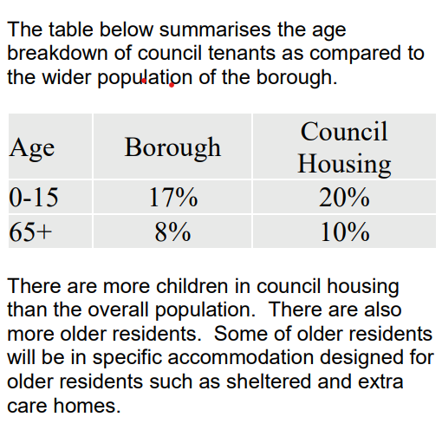 | A greater proportion of households with young people in council housing are likely to be in poverty and suffering deprivation, as are older people, compared to the wider population. The intention of the RES is to create a stronger voice for all tenants and leaseholders; therefore, we anticipate that there will be positive outcomes for all ages.
Equality information on which above analysis is based | Socio-Economic data on which above analysis is based
ONS 2023 data
Census 2021 data
JSNA/Census data

Mitigating and/or improvement actions to be taken
The involvement data shows that people in different age groups tend to engage in different ways using blended approaches to involvement will strengthen age related engagement.  This proposal creates a range of pathways for people to get involved, enables the voice of individuals as well as representative groups, creates different types of scrutiny, and supports a greater number of people taking part.  In addition, we will bring people together to discuss specific issues and policy areas in workshops and focus groups and engage with our residents more formally on key policy areas and in line with our legal duties. | One of the priorities in the strategy is Working together to understand residents’ needs, priorities, and aspirations for their neighbourhoods and communities and collaborating to find practical solutions.  Another key priority is to support community building, helping residents build relationships, networks, and thriving communities.

Disability - A person has a disability if s/he has a physical or mental impairment which has a substantial and long-term adverse effect on that person's ability to carry out normal day-to-day activities.

Please note that under the PSED due regard includes:
Giving due consideration in all relevant areas to ‘’the steps involved in meeting the needs of disabled persons that are different from the needs of persons who are not disabled include, in particular, steps to take account of disabled persons' disabilities.’’ This also includes the need to understand and focus on different needs/impacts arising from different disabilities.

Potential impacts (positive and negative) of proposed policy/decision/business plan; this also includes needs in relation to each part of the duty. | Potential socio-economic impacts/ needs/issues arising from socio-economic disadvantage (positive and negative)
Southwark Council tenants are disproportionately affected by poor health. Almost 1 in 14 rated their health as ‘bad’ or ‘very bad’, compared with only 1 in 25 in the borough’s overall population. | Disabled people are more than twice as likely to be unemployed as non-disabled people. 40% of Council tenant households are deprived in the health and disability category, compared with just over a quarter (26.5%) of all of the borough’s households.
Equality information on which above analysis is based | Socio-economic data on which above analysis is based
ONS 2023 data
Census 2021 data
Mitigating and/or improvement actions to be taken
Blended approaches to involvement will strengthen disability related engagement.  This proposal creates a range of pathways for people to get involved, enables the voice of individuals as well as representative groups, creates different types of scrutiny, and supports a greater number of people taking part.  In addition, we will bring people together to discuss specific issues and policy areas in workshops and focus groups and engage with our residents more formally on key policy areas and in line with our legal duties.  Accessibility is a core principle of our approach. The disability forum identified a need to improve how we engage with neurodiverse residents. Recent engagement has highlighted the need to seek information about participants access requirements. | One of the priorities in the strategy is Working together to understand residents’ needs, priorities, and aspirations for their neighbourhoods and communities and collaborating to find practical solutions.  Another key priority is to support community building, helping residents build relationships, networks, and thriving communities.

Gender reassignment:
- The process of transitioning from one gender to another.
Gender Identity: Gender identity is the personal sense of one's own gender. Gender identity can correlate with a person's assigned sex or can differ from it.
Potential impacts (positive and negative) of proposed policy/decision/business plan; this also includes needs in relation to each part of the duty. | Potential socio-economic impacts/ needs/issues arising from socio-economic disadvantage (positive and negative)
Southwark is the fifth highest ranking local authority in England for residents identifying as trans or non-binary. Within the borough 3,200 residents reporting a gender identity different from their sex registered at birth. Half of these used no specific gender identity term, the rest used ‘trans woman’, ‘trans man’ or ‘nonbinary’. Despite having a relatively high proportion of the population with gender identities that differed from sex assigned at birth, the numbers are likely to be underestimates as many residents declined to answer the question. | There are no identified issues from the proposed RES which we consider could disadvantage residents with this protected characteristic on socioeconomic grounds, other than the general lack of availability of affordable homes in Southwark.
Equality information on which above analysis is based. | Socio-economic data on which above analysis is based
ONS 2023 data
Census 2021 data

Mitigating and/or improvement actions to be taken
It is acknowledged that data on this protected characteristic is incomplete and while ongoing efforts will be made to encourage such information being given. It is expected that the benefits of delivering the RES will help all households.

Marriage and civil partnership – In England and Wales marriage is no longer restricted to a union between a man and a woman but now includes a marriage between a same-sex couples. Same-sex couples can also have their relationships legally recognised as 'civil partnerships'. Civil partners must not be treated less favourably than married couples and must be treated the same as married couples on a wide range of legal matters. (Only to be considered in respect to the need to eliminate discrimination.)

Potential impacts (positive and negative) of proposed policy/decision/business plan | Potential socio-economic impacts/ needs/issues arising from socio-economic disadvantage (positive and negative)
There are no identified issues from the proposed changes which could disadvantage married couples or those in civil partnerships. | There are no identified issues from the proposed changes which could discriminate, or disadvantage married couples or those in civil partnerships.
Equality information on which above analysis is based | Socio-economic data on which above analysis is based
ONS 2023 data
Census 2021 data

Mitigating or improvement actions to be taken
There is no evidence of potential inequality because of the RES for residents identified as having this characteristic. The introduction of the RES will help all households.

Pregnancy and maternity - Pregnancy is the condition of being pregnant or expecting a baby. Maternity refers to the period after the birth, and is linked to maternity leave in the employment context. In the non-work context, protection against maternity discrimination is for 26 weeks after giving birth, and this includes treating a woman unfavourably because she is breastfeeding.
Potential impacts (positive and negative) of proposed policy/decision/business plan; this also includes needs in relation to each part of the duty. | Potential socio-economic impacts/ needs/issues arising from socio-economic disadvantage (positive and negative)
We do not have data on the number of households that are pregnant or in the maternity period | There are socio-economic impacts relating to pregnancy and maternity arising from the lack of suitable housing, but the impact of the RES will be neutral.
Equality information on which above analysis is based | Socio-economic data on which above analysis is based
ONS 2023 data
Census 2021 data
Mitigating and/or improvement actions to be taken
There is no evidence of potential inequality as a result of the introduction of the RES. The core principles that underpin the approach particularly the principle of flexibility and accessibility should ensure improved access to opportunities, as should our blended approaches and menu of opportunities. Our ongoing support of community building embedded in the strategy should mitigate some of the impacts of the reduced income that many face.

Race - Refers to the protected characteristic of Race. It refers to a group of people defined by their race, colour, and nationality (including citizenship) ethnic or national origins. N.B. Gypsy, Roma and Traveller are recognised racial groups and their needs should be considered alongside all others

Potential impacts (positive and negative) of proposed policy/decision/business plan; this also includes needs in relation to each part of the duty. | Potential socio-economic impacts/ needs/issues arising from socio-economic disadvantage (positive and negative)
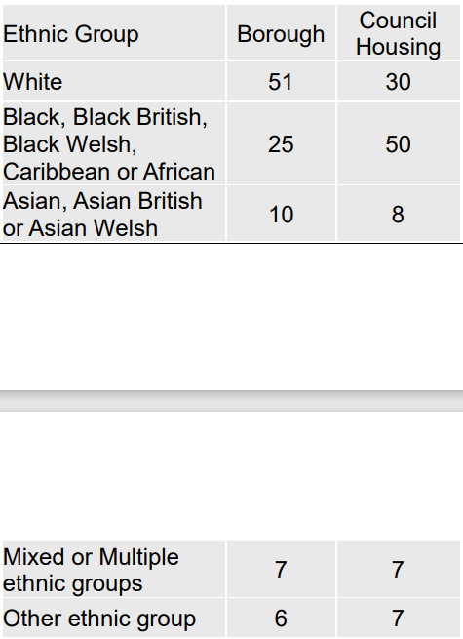  The table above indicates that BAME households and black households, are represented at higher levels in council housing against the general population. | People from some ethnic minority groups including people who are Black, Black African Black Caribbean or Black British are more likely to experience deprivation.
Equality information on which above analysis is based | Socio-economic data on which above analysis is based
Mitigating and/or improvement actions to be taken
The intention of the RES is to increase the involvement for all tenants and leaseholders,
therefore, we anticipate that there will be positive outcomes for all races. The strategy recognises the disadvantage that people from our Black Asian and minority ethnic communities face and sets out that residents stressed the importance of inclusivity and fairness and told us that
engagement must reach those who are often underrepresented. We will ensure that our involvement structures reflect the full diversity of Southwark’s communities, across tenure, age, ethnicity, gender, disability and lived experience. This means using a mix of approaches, from events to targeted outreach and digital platforms to engage groups who might otherwise be left out. By embedding meaningful engagement with visible impact, we will create an environment where every voice is valued and where decisions are shaped by the breadth of perspectives in our borough. The strategy sets out as one of its objectives to reduce inequality, empower people, and invest in prevention.

Religion and belief - Religion has the meaning usually given to it but belief includes religious and philosophical beliefs including lack of belief (e.g. Atheism). Generally, a belief should affect your life choices or the way you live for it to be included in the definition.

Potential impacts (positive and negative) of proposed policy/decision/business plan; this also includes needs in relation to each part of the duty. | Potential socio-economic impacts/ needs/issues arising from socio-economic disadvantage (positive and negative)
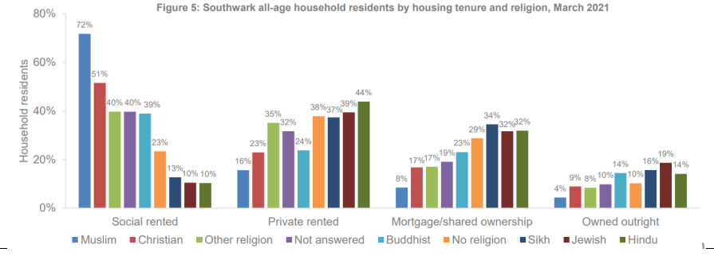

The chart above shows that disproportionately more households that declared themselves as muslim (71%) and Christian (51%) live in social housing compared to other tenures.

Equality information on which above analysis is based | Socio-economic data on which above analysis is based
ONS 2023 data Census 2021 data

Mitigating and/or improvement actions to be taken
We anticipate positive outcomes for residents from the RES, regardless of religion. Significant proportions of our faith communities live in council homes reaching these residents through their faith communities should prove a beneficial way of reaching some of our residents. Almost three quarters of the boroughs muslim population are living in council homes.

Sex - A man or a woman.

Potential impacts (positive and negative) of proposed policy/decision/business plan; this also includes needs in relation to each part of the duty. | Potential socio-economic impacts/ needs/issues arising from socio-economic disadvantage (positive and negative)
In terms of council tenants, women are overrepresented in terms of heads of household - 55% as opposed to 45% men. Some of these households are female lone parents. | Sex is an issue in relation to economic status with women being adversely impacted. Research nationally suggests that women are more likely to be lone parents and equally experience lower levels of economic activity than men.
Equality information on which above analysis is based | Socio-economic data on which above analysis is based
ONS 2023 data
Census 2021 data
Mitigating and/or improvement actions to be taken
More women have taken part in the engagement on this strategy this suggests that women are more likely to get involved than men. The differences are greater than the difference in heads of household data set out above. As we build strategies for engagement on individual projects, we will need to consider how to ensure that men also take part.

Sexual orientation - Whether a person's sexual attraction is towards their own sex, the opposite sex or to both sexes

Potential impacts (positive and negative) of proposed policy/decision/business plan; this also includes needs in relation to each part of the duty. | Potential socio-economic impacts/ needs/issues arising from socio-economic disadvantage (positive and negative)
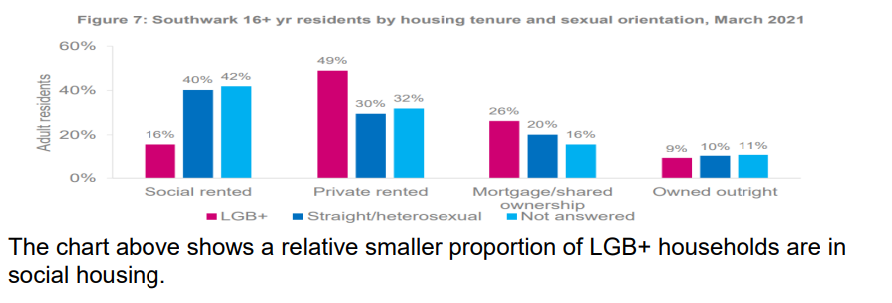
Equality information on which above analysis is based | Socio-economic data on which above analysis is based
ONS 2023 data Census 2021 data

Mitigating and/or improvement actions to be taken
It is acknowledged that data on applicants’ sexual orientation is incomplete, with a significant proportion of households not responding to this question, ongoing efforts will be made to encourage such information.

Human Rights
There are 16 rights in the Human Rights Act. Each one is called an Article. They are all taken from the European Convention on Human Rights. The Articles are The right to life, Freedom from torture, inhuman and degrading treatment, Freedom from forced labour , Right to Liberty, Fair trial, Retrospective penalties, Privacy, Freedom of conscience, Freedom of expression, Freedom of assembly, Marriage and family, Freedom from discrimination and the First Protocol

Potential impacts (positive and negative) of proposed policy/decision/business plan
The RES is intended to improve the quality of residents’ homes and their estates by ensuring they have a stronger voice to shape and influence housing services. All steps will be taken
to respect the confidentially of residents and that they are treated with respect.
Information on which above analysis is based

ONS 2023 data
Census 2021 data
Council records

Mitigating and/or improvement actions to be taken
The Council provides support to residents who need help with accessing the service. Applicants will be invited to be involved as much as possible in the way services are designed and delivered and have full opportunity to express any views through consultations, satisfaction surveys and user panels etc.

Conclusions

From the analysis above, in comparison to the wider population council homes:
• Have more children and older people
• Suffer from higher levels of ill-health and disability
• Have a larger number of households headed by females
• Have higher levels of households from a BAME ethnicity
• Suffer from higher levels of deprivation and poverty
• Households from a Muslim or Christian background are more likely to be living in council homes than other tenures.

Poor quality housing is often associated with poor health and has wider negative impacts on welfare. The ambition of the RES is that we will fundamentally improve the quality of homes though giving residents an ability to shape policy and scrutinise performance.

Section 5: Further equality actions and objectives

5. Further actions
Based on the initial analysis above, please detail the key mitigating and/or improvement actions to promote equality and tackle inequalities; and any areas identified as requiring more detailed analysis.
Number | Description of issue | Action | Timeframe
1 | Monitor the Scheme | Undertake an  Equality  Analysis | January 2028

5. Equality and socio-economic objectives (for business plans)
Based on the initial analysis above, please detail any of the equality objectives outlined above that you will set for your division/department/service. Under the objective and measure column please state whether this objective is an existing objective or a suggested addition to the Council Plan.
Objective and measure | Lead officer | Current performance (baseline) | Targets
Objective and measure | Lead officer | Current performance (baseline) | Year 1 | Year 2
 | As above

6. Review of implementation of the equality objectives and actions

Implementation Equality Impact and Needs Analysis

